Welcome to the thingSoC® Teensy3x Adapter Board
The TSOC_Teensy3x is an adapter for the excellent Teensy Development Board from PJRC.
The TSOC_Teensy3x allows you to connect thingSoC , Mikrobus , and/or Grove System Modules all at the same time, either standalone, or with any other thingSoC Processor or Radio module. This gives you maximum flexiblity for sensor and actuator selection and reuse.
Assembling the TSOC_Teensy3x :
If you have purchased just the adapter board by itself, you will need to do a little soldering to assemble the unit. The TSOC_Teensy3x was designed using easy to solder through-hole components, so it would be simple to assemble for even the most inexperienced user.
1) Insert male pins into the Teensy outline. MAKE SURE to put the "short side" down, into
the holes, and the "long side" of the pins on the top side, so that the Teensy has enough space to
clear the "grove" connecters and solder them securely.
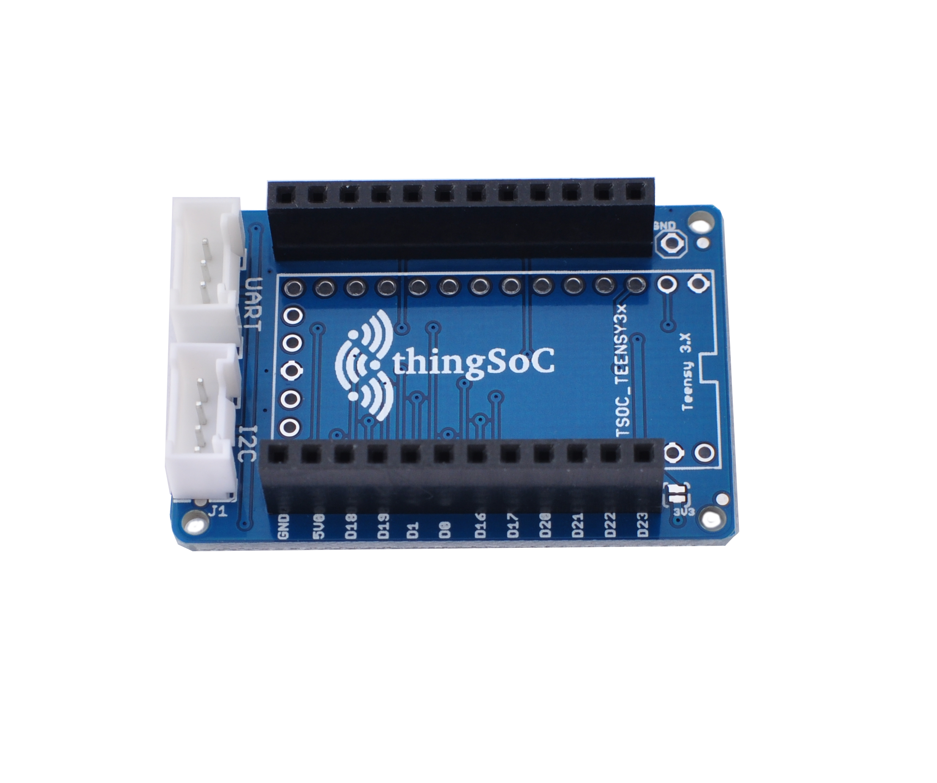

5) Then attach the Teensy3.2 board, and solder it securely from the top side.
In the example below, we used a female connector on the end cap for access.
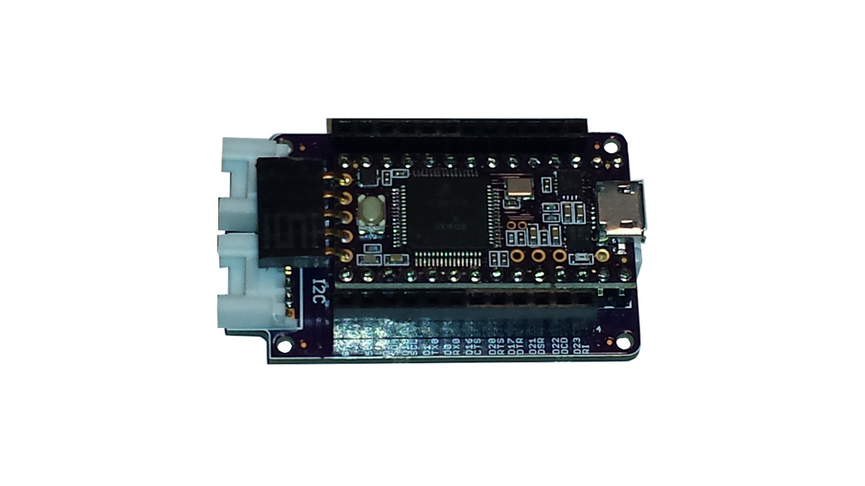
Download and Install Teensyduino :

Teensyduino is a software add-on for the Arduino IDE, developed for the Teensy by PJRC.
1) Download and install the Arduino IDE from :
https://www.arduino.cc/en/Main/Software

2) Download and install the Teensyduino package :

https://www.pjrc.com/teensy/td_download.html
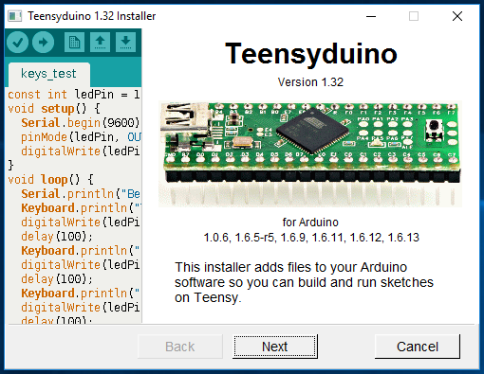
3) Run the Teensyduino Installer :

4) When using Arduino, be sure to select Teensy in the Tools > Boards menu.
Arduino's File > Examples menu automatically changes to show the libraries and examples
for the selected board.

Getting Started :
1) Using a USB-Micro cable, plug the TSOC_Teensy3x board into your Windows, MAC, or Linux PC.
2) The drivers should be found automatically on most systems.
However if they are not, they can be downloaded from :
https://www.pjrc.com/teensy/td_download.html
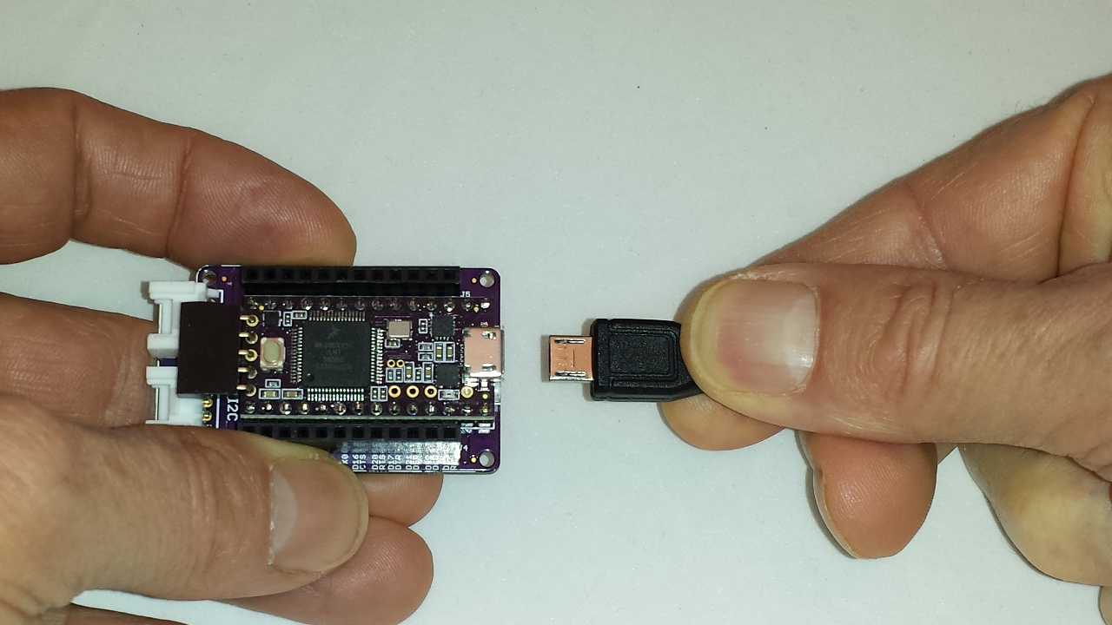
3) With the default firmware, when the TSOC_Teensy3x board is first connected to power,
the onboard LED will begin to blink slowly.
Safe Handling Precautions :
1) Always remove/unplug all power before inserting or removing peripherals.
2) Always ground yourself by touching a ground point before handling your boards.
3) Use a static safe bag when transporting your TSOC_Teensy3x board.


Supported Peripherals :
The TSOC_Teensy3x board supports thingSoC, Grove, and Mikrobus peripherals.
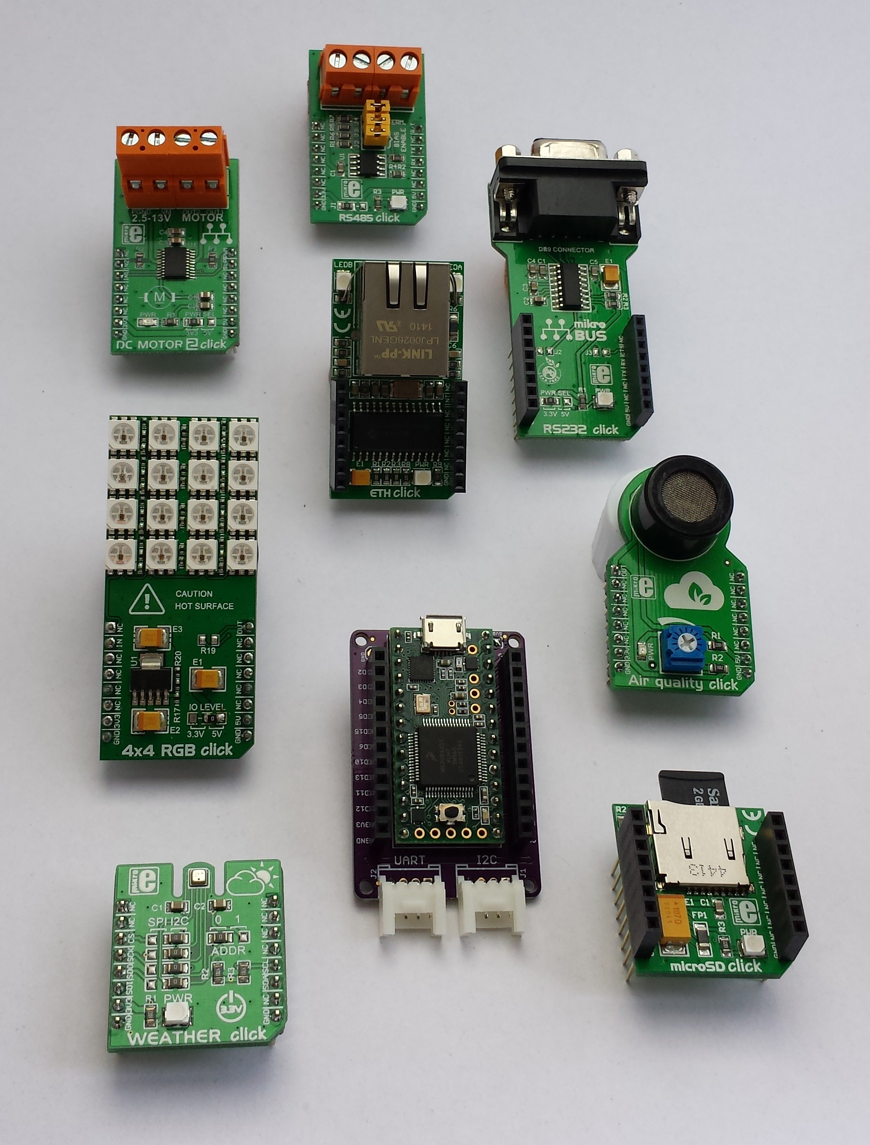
Attaching Mikrobus Peripherals :
1) Any 3.3 Volt compatible Mikrobus peripheral may be directly connected to the TSOC_Teensy3x.
2) Make sure to align the SQUARE/CUT edges of the boards together to insure that
the polarity is correct. Push down evenly to seat the boards in the socket.
3) Note that the "stacking pins" are somewhat longer by design, and there will be some
extra space between the boards when using stacking connectors.
4) Note that Mikrobus is only sixteen (16) pins while thingSoC is twenty-four (24) pins, make sure
to align the smaller Mikrobus board to the back edge of the TSOC_Teensy3x
(i.e. Ground to Ground) as shown :
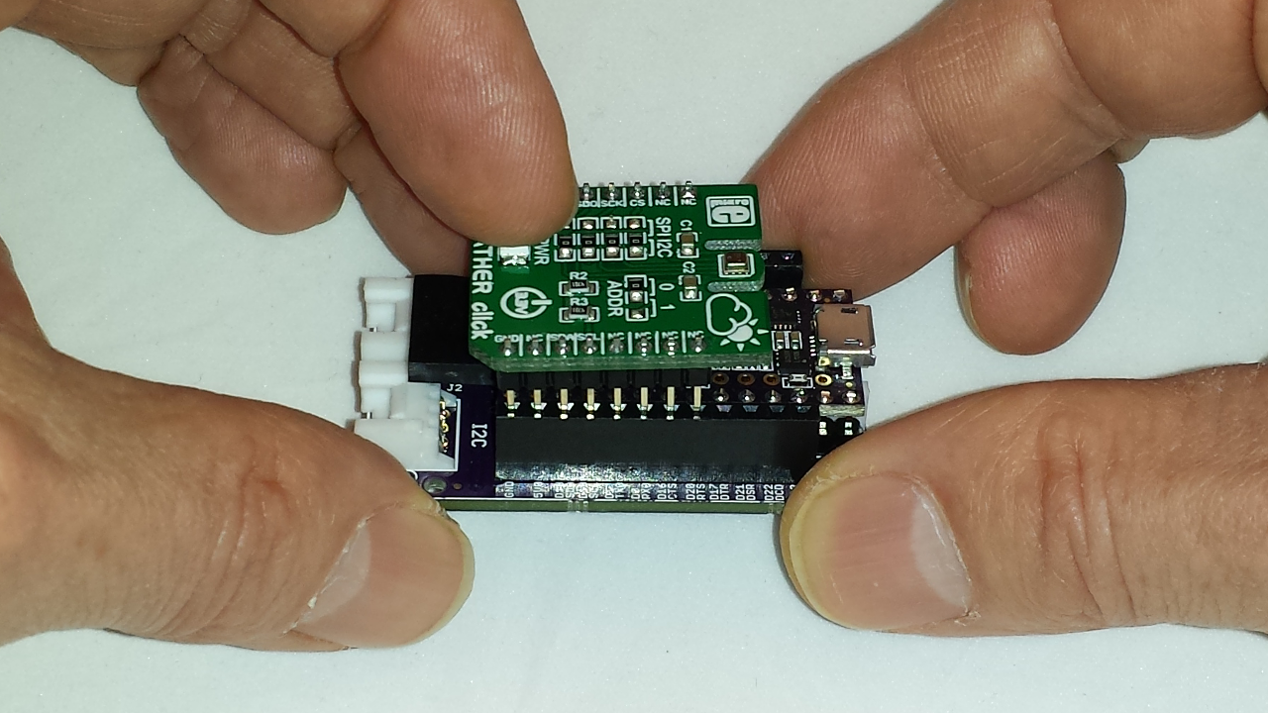
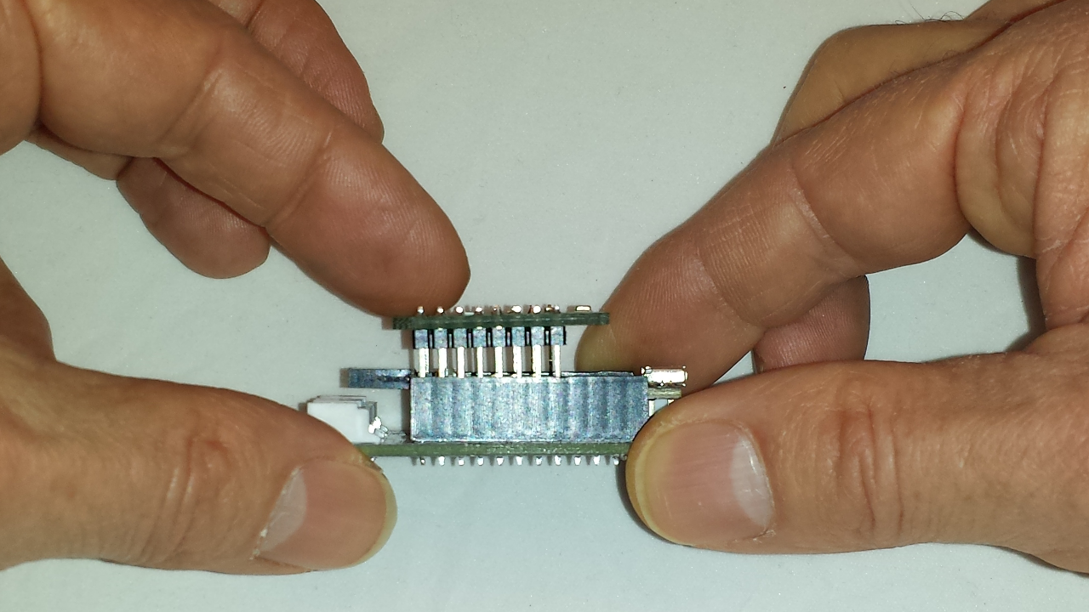

MikroElecktronika Click® Boards:
The TSOC_Teensy3x is compatible with most 3.3 Volt Click® boards, available at Digikey, Mouser and from Mikroelectronika direct. There are already hundreds of boards available to just plug in!
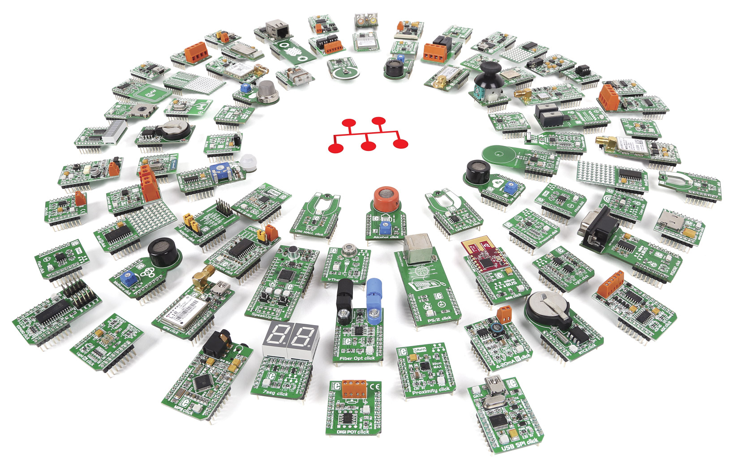

Attaching Grove Peripherals :
1) As shown below, there are three(3) white "Grove" connectors, and they are named,
UART - (Serial #3 , using Teensy3x pins D7 and D8 )
I2C - (I2C #0, using Teensy3x pins D18 and D19 )
ANALOG - (Using Teensy3x pins A0 and D9)
Note : All of these pins are connected directly to the Teensy and are 3.3 Volt levels only.
Do Not connect 5.0 Volt peripherals to these pins, or you may damage your Teensy!
(we have the thingSoC I2C Hub, GPIO, and ADC for connecting 5.0 Volt peripherals!)
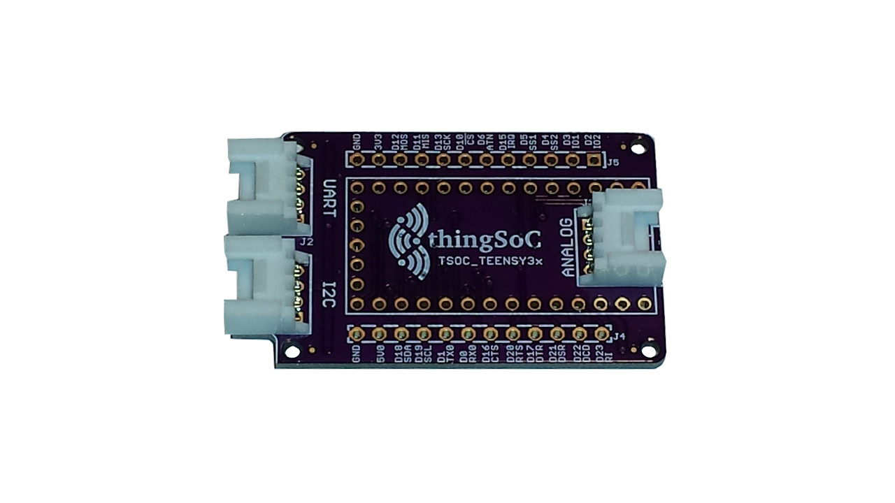

2) Any 3.3 Volt compatible Grove peripheral may be connected
directly to the TSOC_Teensy3x, there are dozens of sensors and actuators available from
the Seeedstudio Bazaar.
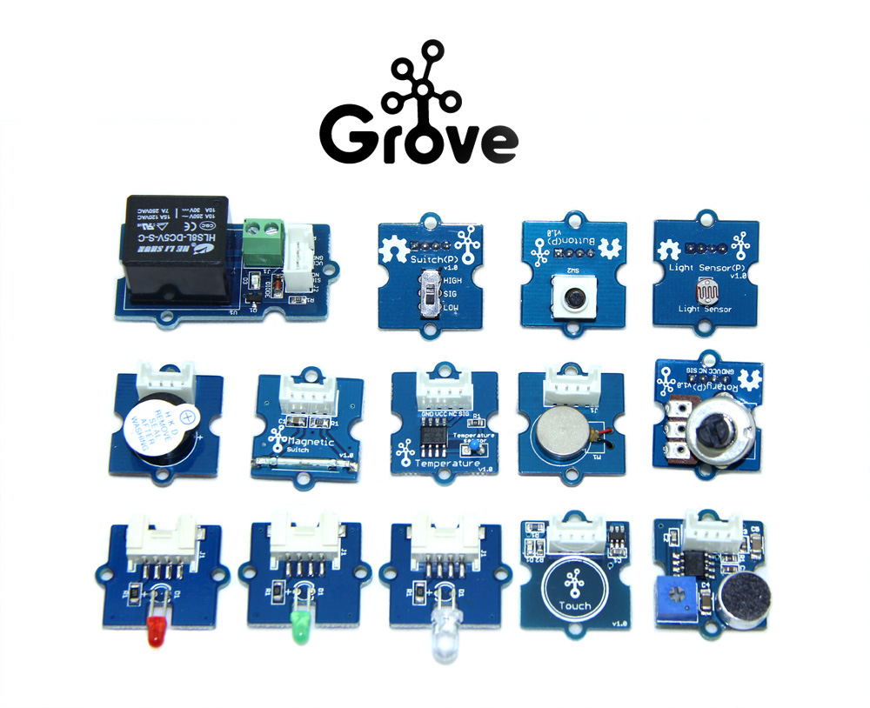

Basement Water/Flooding Sensor and Pump Relay Example :
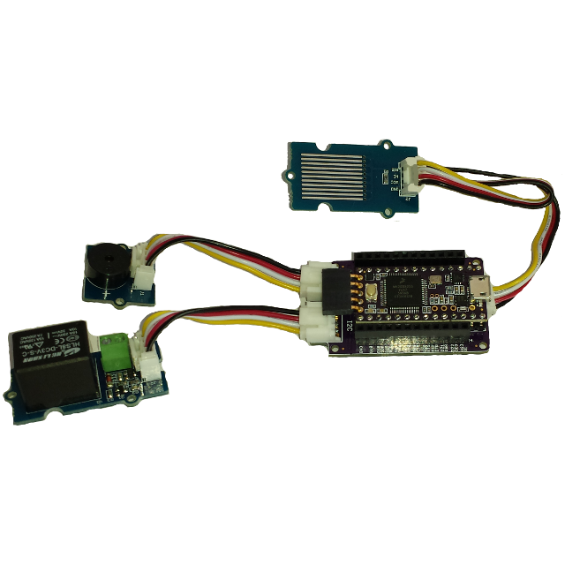
The example circuit
shows a simple water sensor, with an audio buzzer output and a
relay control to activate
a water pump.

When water is detected by the sensor, the buzzer sounds and the relay engages to activate a water pump (not shown).

The code is available in the TSOC_Teensy3x examples directory.
Teensy 3.2 Features :
The TSOC_Teensy3x is a low cost, embeddable module featuring a MK20DX256VLH7 device :
- 72/96 MHZ ARM Cortex-M4F Processor (Freescale)
- USB Full-Speed Controller
- 256K Bytes Flash Memory
- 64K bytes RAM Memory
- 2048 bytes EEPROM memory
- Serial Communication (3 Ports)
- Counter/Timers/PWMs (12)
- CAN (controller area network) Controller
- I2C controllers (2)
- USER LED
- USER Pushbutton
- thingSoC Compliant Module
- Mikrobus Compatible Module

Top Side :
(From https://www.pjrc.com/teensy/pinout.html )

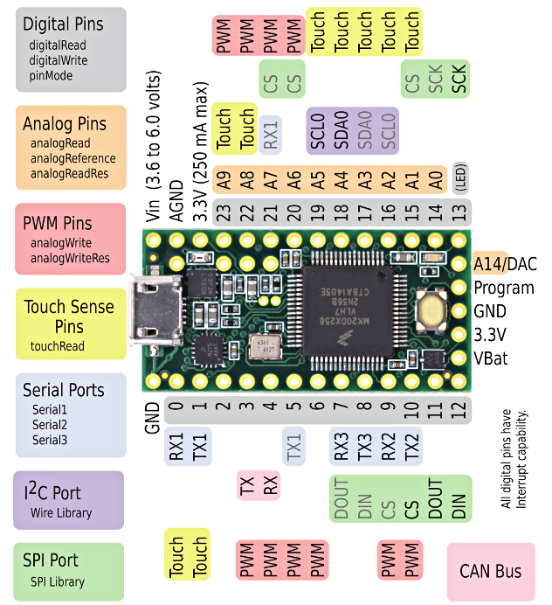

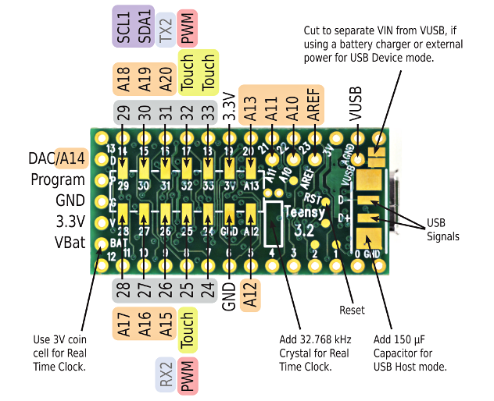
Rear Side :
(From https://www.pjrc.com/teensy/pinout.html )

thingSoC® Teensy3x Adapter Board Errata

Products Affected : Revision 1 (Blue) Boards
#1) SPI Wiring Reversed :
The initial (Rev 1) "Blue" TSOC_Teensy3x boards have the hardware SPI pins reversed,
(the MISO and MOSI pins reversed). Most Arduino librarys will let you specify the
SPI pins to be used explicitly, but will use software (bit-bang) SPI when you do that.
Most users are able to work around this ssue. If this is a problem for your application,
contact us for a Revision 2.0 board, which will be available in 3-4 weeks.

Revision 2.0 (Purple, Black) boards are NOT affected by Errata #1



